* How to open CRM Software on Chrome
* 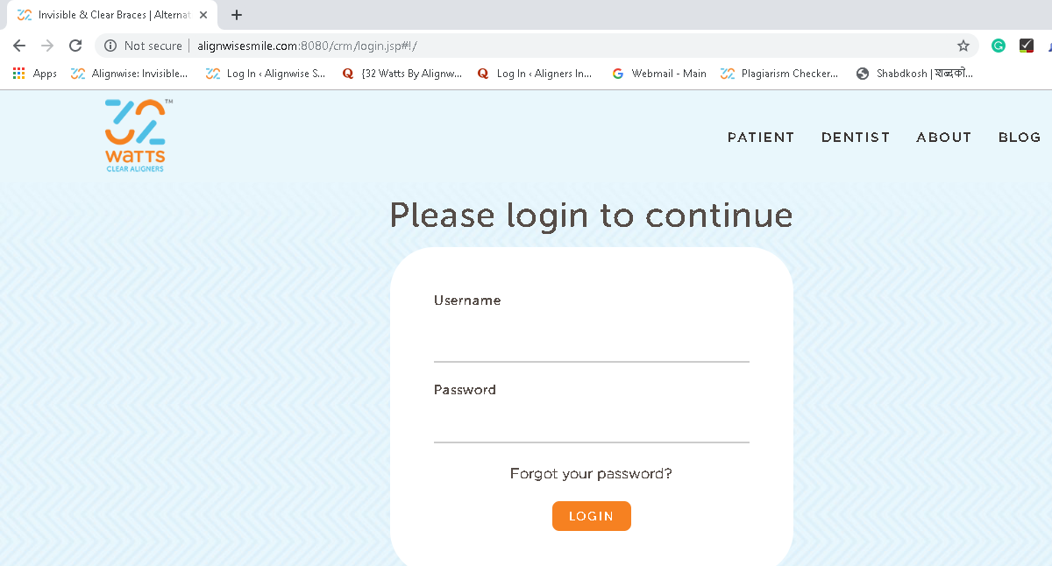Link: <http://alignwisesmile.com:8080/crm/login.jsp#!/>
* How to login to CRM Software
* Enter your username.
* Enter the password.
* Then click on Login Button.

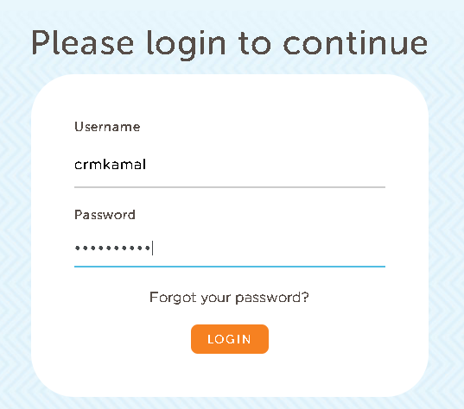

* How to redirect to 32watts.com from CRM Login page
* Click on PATIENT at the right top of the page.



* How to redirect to blogs from CRM Login page
* Click on BLOGS at the right top of the page.

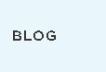

* Redirect links from the footer or bottom of all pages of CRM software.
* Button: Patient

link: <https://www.32watts.com/>

* Button: About

link: <https://www.32watts.com/about.html>

* Button: Blog

link: <https://blog.32watts.com/>

* Button: Facebook Icon

link: <https://www.facebook.com/32watts>

* Button: LinkedIn Icon

link: <https://www.linkedin.com/company/alignwise-smile-technologies/>

* Button: Youtube Icon

link: <https://www.youtube.com/channel/UC2Xgt_zC4ZWvKISMzzwmMbg>

* How to add Doctor
* Click Add button at the top.

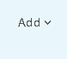

* Then from dropdown select Add Doctor.

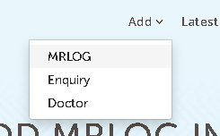

* 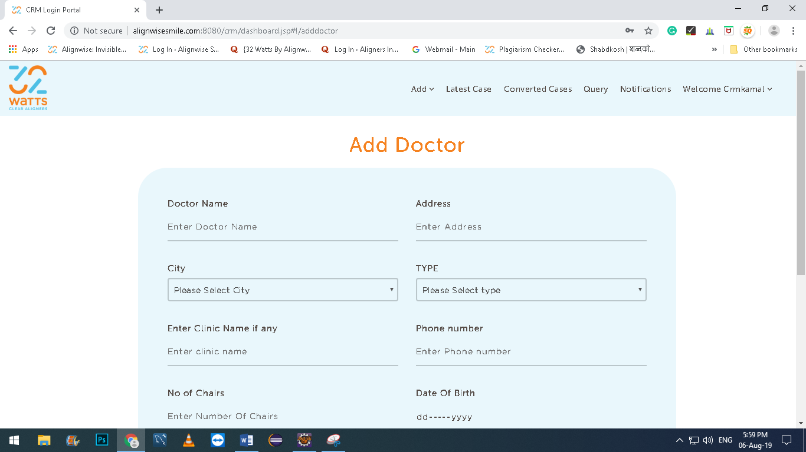To add a doctor screen will appears.
* Fill up all Enteries.
* All entries are must filled. (except Enter Clinic Name if any)
* Then click on SUBMIT button.

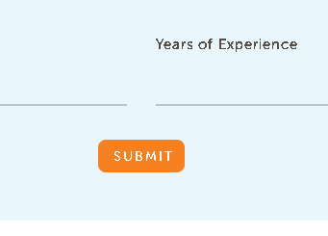

* Alert is pop up “DOCTOR ADDED”.

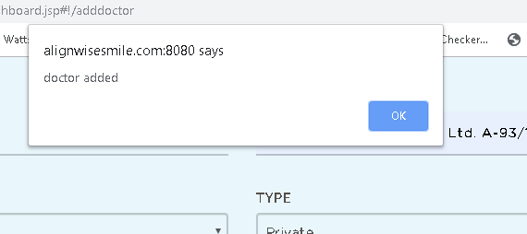

* Click on ok.
* How to add MRLOG
* Click Add button at the top.



* Then from dropdown select Add Mrlog.



* To add MRLOG screen will appears.

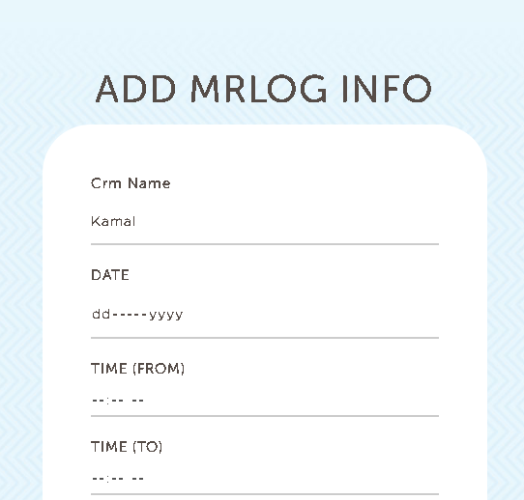

* Fill up all Entries.
* All entries are must filled.

except:

* **Order quantity**
* Order booked
* **Expected Delievery Date**
* **Actual delievery date**
* **Remarks**
* Then click on SUBMIT button.

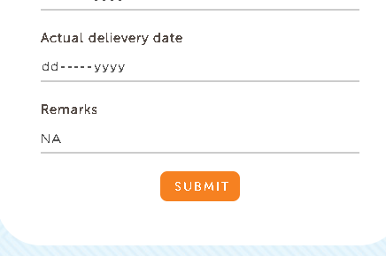

* Alert is pop up “MRLOG ADDED”.

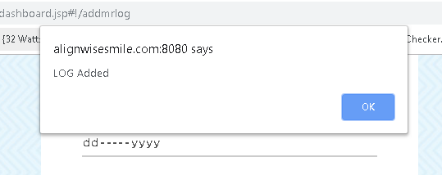

* Click on ok.
* How to generate Enquiry
* Click Add button at the top.



* Then from dropdown select Add Enquiry.



* To add Enquiry screen will appears.

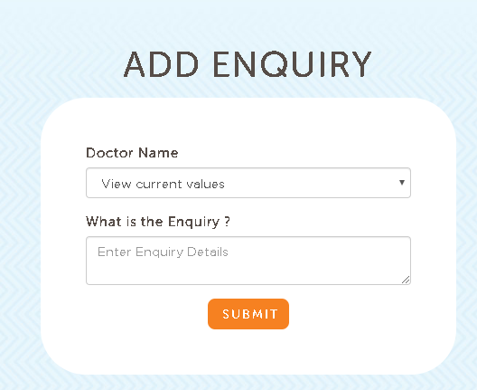

* Fill up all Entries.
* All entries are must filled.
* Then click on SUBMIT button.
* Alert is pop up “ENQUIRY ADDED”.

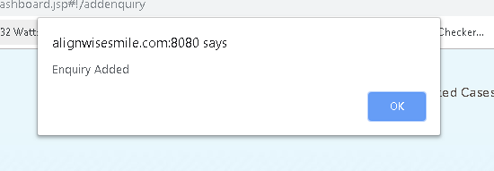

* Click on ok.
* To view added mrlogs
* Click on Latest Case button at the top.

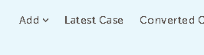

* Add filters according to you.
* And click on search.
* You can clear all filters by clicking on clear filters.
* 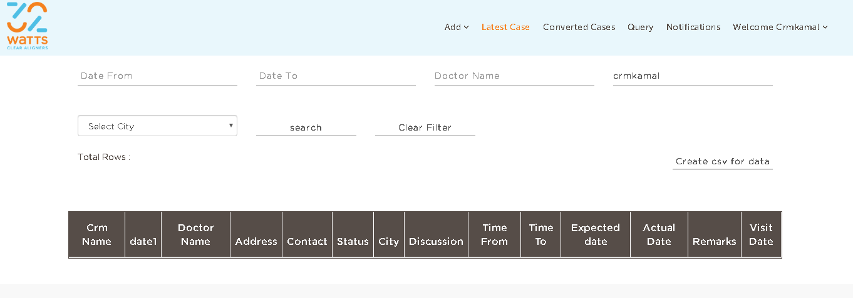You can generate a excel file by clicking on generate CSV.
* To convert added enquiries directly into cases
* Click on Converted Cases button at the top.



* 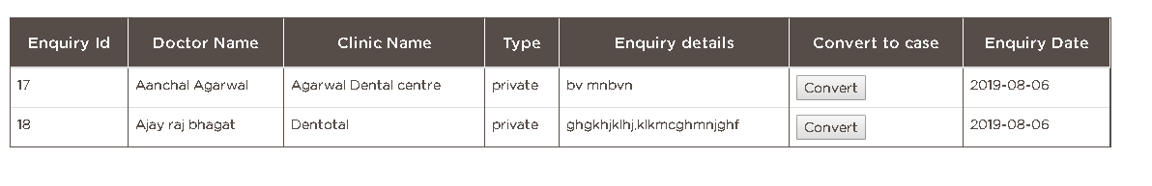All the enquiries list opened in the form of tables.
* Then click on convert.
* Alert ask from you about confirmation.

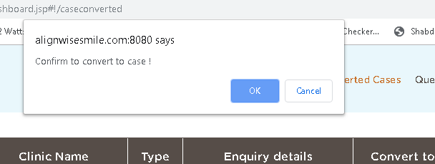

* Then alert shows you that case is converted successfully.

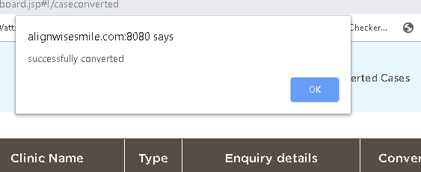

* Click ok.
* How to logout from CRM Software
* Click on welcome Crmkamal button at the top.



* Dropdown menu opened.

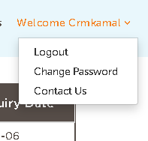

* Select logout.
* How to Check Enquiries from admin Id
* Click on check Enquiries after login at the top.

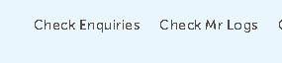

* If don’t want to add any filter and want to generate excel file then click on Create CSV for data button at the left.
* For adding filters, click on three lines small symbol at the top left.
* Then add filters according to you.
* And click on search.
* 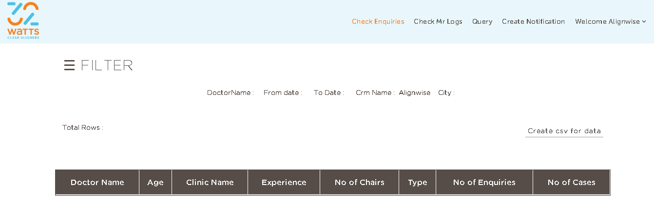You can remove all filters by clicking on clear filters.

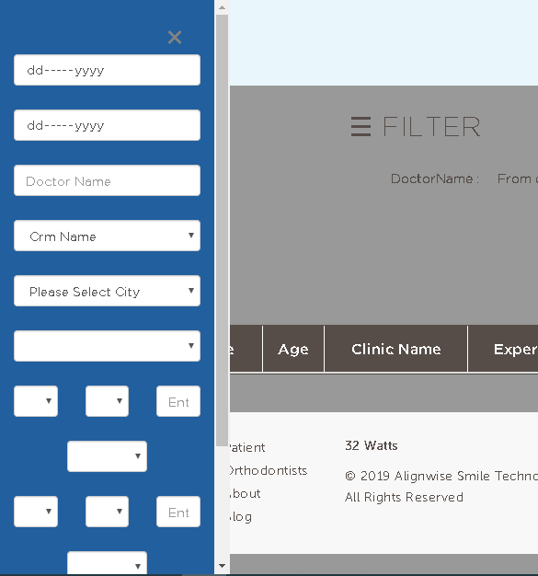

* How to Check Mrlogs from admin Id
* Click on check mrlogs after login at the top.



* Add filters according to you.
* And click on search.
* You can clear all filters by clicking on clear filters.
* You can generate a excel file by clicking on generate CSV.

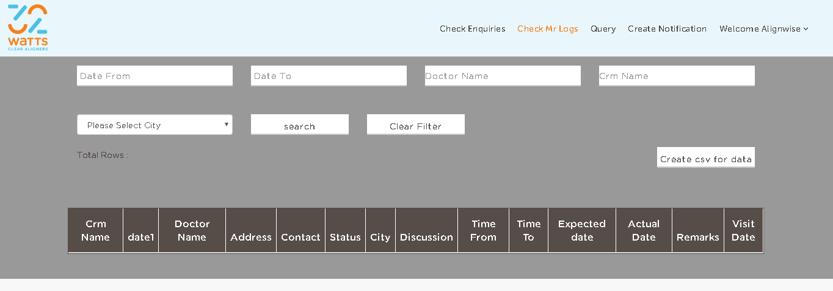

* 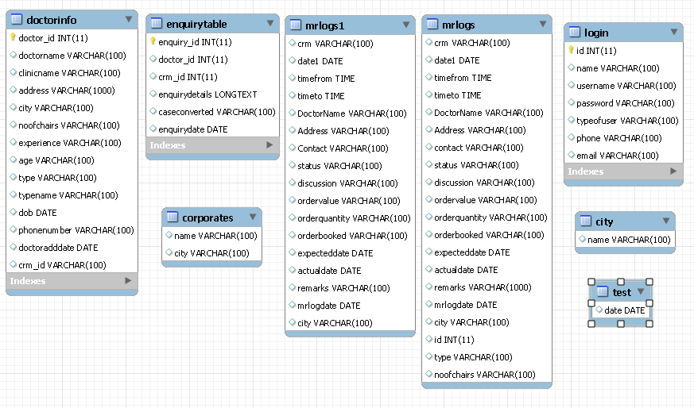Database Structure of CRM Software